Chapter 13, Problem 34.

Using Fig. 13.103, design a problem to help other students better understand how to find the input impedance of circuits with transformers.
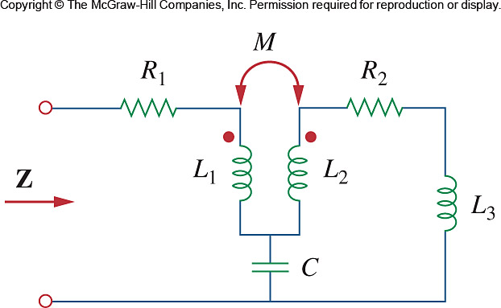

Figure 13.103
For Prob. 13.34.

